Chisholm’s

COVIDSafe Plan

9 November 2022 V4.10

Table of Contents

1. Introduction 3
1.1. Purpose 3
1.2. Overview 3
1.3. Campus Locations 3
1.4. COVIDSafe Plan Contacts 4
1.5. Chisholm COVID-19 Safety Documents 4
1.6. Abbreviations 4
1.7. References 5
2. COVIDSafe Plan 6
2.1. Hygiene 6
2.2. Cleaning 7
2.3. Physical distancing 7
2.4. Limiting workplace attendance 8
2.5. Record Keeping 10
2.6. Response to a suspected or confirmed COVID-19 case 10

Introduction

Purpose
Chisholm’s COVIDSafe Plan (The Plan) covers Chisholm Institute and its controlled entities Chisholm Online and the Caroline Chisholm Education Foundation.
This plan sets out the processes, actions and plans that are in place to:
- Prevent the introduction or potential spread of coronavirus (COVID-19) to employees, students, contractors, workplace participants, or visitors to our workplace
- Comply with all government directions, legislations, regulation, restrictions, and requirements to manage our employer responsibilities.
This COVIDSafe Plan will be reviewed and updated routinely when restrictions or public health advice changes. The Plan is not meant to conflict with any statutory requirements, if any anomalies exist the public health directions shall be followed.

Overview
COVID-19 is new strain of coronavirus previously not identified in humans and for this reason we all need to adjust to new precautions to protect the Chisholm Community.
Chisholm is actively monitoring the spread of COVID-19 and is receiving advice from relevant health and government authorities in managing our response.
As a TAFE provider, Chisholm remains an essential service and continues to operate. Whilst online and remote work is being undertaken, onsite curriculum delivery is still a fundamental component to our service offerings.
This information is provided to ensure their continued health, safety, and wellbeing when on campus. It is expected that all employees, students, contractors, workplace participants, and visitors follow the COVIDSafe Plan and developed safety protocols effective immediately and until further notice.
This extends to ensuring legal compliance, risk management and the provision of a safe working environment for all persons that may be affected by Chisholm Institute.

Campus Locations
Chisholm Institute’s COVIDSafe Plan applies to following Campus locations:
- Bass Coast - Corner Bass Highway and South Dudley Road, Wonthaggi, 3995.
- Berwick - 25 Kangan Drive, Berwick VIC 3086
- Chisholm at 311 - 311 Lonsdale Street Dandenong, 3175
- Cranbourne - 2 New Holland Drive, Cranbourne East, 3977
- Dandenong - 121 Stud Rd, Dandenong, 3175
- Frankston – Fletcher Rd, Frankston, 3199
- Springvale – Corner Boulton St and Springvale Rd, Springvale, 3175
- Mornington Peninsula – Boneo Rd, Rosebud 3939

COVIDSafe Plan Contacts
Any queries in relation to Chisholm’s COVIDSafe Plan can be directed to the following contacts:
Name | Position | Telephone | Email
Andrew Holland | Manager - Occupational Health, Safety & Operational Resilience | 9212 4721  0481 478 103 | andrew.holland@chisholm.edu.au
Bradley Harris | Covid Response  Senior Business Partner | 9212 4763  0408 551 663 | bradley.harris@chisholm.edu.au

Chisholm COVID-19 Safety Documents
Chisholm have developed the following Safety Protocols and forms to support our COVIDSafe Plan:
- Safety Protocols for Onsite Curriculum Delivery
- Safety Protocols for Professional and Support Staff
- Safety Protocols for Personal Protective Equipment Usage - COVID-19
- Safety Protocols for Working at Third Party Worksites - COVID-19
  - COVID-19 Third Party Worksite Training Checklist
- Safety Checklist for Shared Use (Pool) Vehicles - COVID-19
- Cleaning Guidelines for COVID-19 Pandemic
- Rapid Antigen Testing guidelines
- Covid-19 Multi location workers guidelines

Abbreviations
- COVID-19 - Coronavirus disease 2019
- DHHS - Department of Health and Human Service
- DET - Department of Education and Training
- VCE - Victorian Certificate of Education (VCE)
- VCAL - Victorian Certificate of Applied Learning
- VETDSS Victorian Education and Training Delivered to Secondary Students

References
The following references are utilized in the development of this plan:
- Coronavirus (COVID-19) Victoria website -- https://www.coronavirus.vic.gov.au/
- WorkSafe: Managing COVID-19 risks – face coverings in workplaces
- DHHS: Preventing infection in the workplace
- DHHS: Preparing for a case of coronavirus (COVID-19) in your workplace
- DHHS: Planning and responding to cases of coronavirus (COVID-19)
- DHHS: Cleaning and disinfecting to reduce COVID-19 transmission
- DHHS: Cleaning and disinfecting to reduce COVID-19 transmission tips for non-healthcare settings
- WorkSafe: Other relevant industry specific guidance

COVIDSafe Plan
To protect our employees, students, contractors, workplace participants and visitors, Chisholm has implemented a wide range of measures to support good hygiene practices and to prevent the spread of COVID-19. To this end, Chisholm have implemented the following measures:

Hygiene
Chisholm have the following measures in place to manage hygiene:
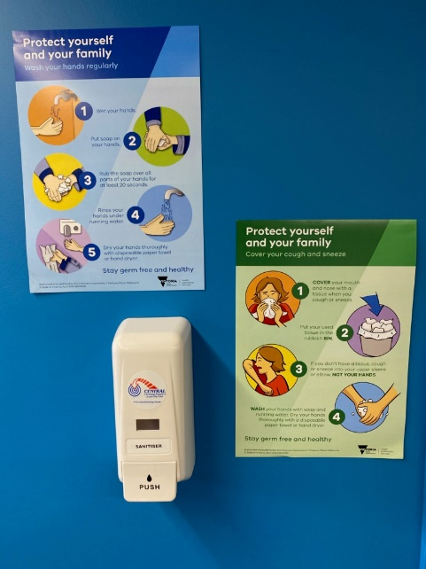
- Installed wall mounted hand sanitisers at building’s entrances and in high traffic locations.
- Established alcohol-based hand sanitisers and wipe stations at frequently utilised areas such as receptions, lunchrooms, classrooms, and workshops so that all communally used surfaces (desks, benches, keyboards, computer mice, tools & equipment) can cleansed by employees or students, before and after use.
- Provision of adequate supplies of hand soap and paper towels for employees and students including ensuring rubbish bins are readily available.
- Provision of information and education on how to wash and sanitise hands correctly and how to wear face masks/required Personal Protective Equipment (PPE).
- Mask wearing in indoor and crowded settings is strongly recommended. Masks are available for employees from Security as per the RAT distribution guidelines. For placement requirements, staff and students may be required to wear a mask in alignment with industry requirements e.g health care.
- Where possible, windows and air conditioning are set for optimum air flow.
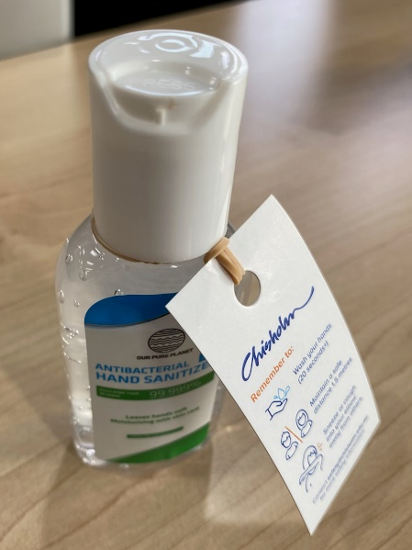
- Employee and students have been educated on and received regular reminders to practice good hygiene measures:
  - Regularly wash or sanitise your hands
  - Practice good sneeze/cough hygiene
  - Avoid touching your face and sharing equipment
  - Clean any shared workstation/workspace
  - Avoid touching objects unnecessarily with your hands.
- Displayed posters on good hygiene practices and social/physical distancing requirement in high traffic areas as a visual reminder for everyone to follow.
- Employee and students are assigned their own equipment/materials/work zones where possible to minimise sharing of communal items.

Cleaning
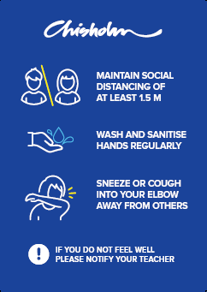
Chisholm has implemented the following measures to manage cleaning:
- Implemented an enhanced cleaning schedule to ensure surfaces that employees, students, contractors, or visitors may touch frequently (e.g., light switches, door handles, lift buttons etc.) are cleaned and disinfected (a minimum 2 times a day).
- Cleaning schedule implemented which ensures work areas and classrooms/workshops are cleaned between each scheduled shift or class. Sanitiser and wipes are provided in each fleet car for use. Fleet cars are cleaned and disinfected once a week.
- Adequate stockpiles of cleaning supplies and products (e.g., detergent and disinfectant) are maintained and regularly restocked.
- Developed Cleaning Guidelines for COVID-19 Pandemic to provide guidance on recommended cleaning routines.

Physical distancing
Chisholm has implemented the following measures to support physical distancing:
- Physical barriers to separate work zones have been established to enable adequate spacing in work and reception areas (e.g., sneeze guards in reception areas).
- Work/education areas (e.g., offices, meeting rooms, classrooms, workshops, reception areas) have been setup to assist in supporting 1.5 metres social distancing, where possible.
- Installed floor markings that mark out acceptable spacing in workshops and reception areas.
- From the 18th February 2022, all density quotients are no longer in place.
- Education and training have been provided to employees and students on physical distancing expectations (including signage to remind and reinforce messaging).
- Where possible avoid ride sharing in shared use (pool) vehicles If not possible, all occupants are recommended to wear a face mask.

Limiting workplace attendance
To support working arrangements to limit workplace attendance Chisholm has implemented:
- COVID-19 Vaccination Requirements Policy (QMS430 and QMS430_01) and
- Flexible Work Policy - Professional and General Employees (QMS227, QMS227_01, QMS227_02, and QMS227_03)
Employees, contractors and workplace participants can only attend campus if
- they have been double vaccinated (unless they are an excepted person): and
- records of their vaccination’s status or exemption have been submitted / confirmed to Chisholm in accordance with QMS430 – COVID-19 Vaccination Requirements Policy.
Students on campus
- No longer will be required to show evidence of vaccination or hold a valid medical exemption to attend Chisholm Campus.
- Students are encouraged to work and /or study remotely if they have a cold, flu or COVID symptoms, including coughing, sneezing, runny nose, or fever.
- Students are encouraged to use Rapid Antigen Test (RAT) if they are experiencing symptoms or have been a close contact of a COVID case, prior to attending on campus
Vaccination requirements for Placement
Students attending placement will need to comply with the requirements of their host, which may include masks or vaccination requirements. The Victorian State Government has indicated six industry areas requiring mandatory three dose vaccination. These industry areas are:
- Residential Aged Care Facility workers
- Healthcare workers
- Disability workers
- Custodial workers
- Emergency services workers, and
- Education workers at Specialist Schools
In addition, individual employers may impose their own vaccination requirements. Therefore, if you are not vaccinated, you may not be able to complete the full requirements of the course.

Vaccination is still considered the best way to protect yourself, family, friends, classmates and teachers from major illness associated with the virus. Getting vaccinated will help slow the spread of COVID-19 and prevent extensive outbreaks across our community.

Requirements for staff/students who test positive for COVID-19
- Employees, workplace participants and students who return a positive PCR or RAT for COVID-19 must not attend campus for at least 5 days and until no more symptoms
- Employees, workplace participants and students who return a positive PCR or RAT for COVID-19, are recommended to isolate for at least 5 days or up to 7 days.
  - The isolation period begins on the day the positive test was taken.
  - On the 6th day of isolation, those with (sore throat, runny nose, cough or shortness of breath) symptoms – no matter how mild, may still be infectious and are recommended to isolate.
  - On the 6th day of isolation, those with no symptoms are free to leave isolation on that same day, without taking a test to leave isolation. Those leaving isolation on day 6 should wear a mask for 5 days but particularly the first 2 days. During these first 2 days, the following are recommended:
    - Do not visit a hospital or aged care facility
    - Do not attend work at a hospital, residential aged care facility, disability care facility and in-home care premises (including disability and aged care in the home).
  - On the 7th day of isolation, those with (sore throat, runny nose, cough or shortness of breath) symptoms – no matter how mild, may still be infectious and are recommended to isolate.
  - On the 7th day of isolation, those with no symptoms are free to leave isolation on that same day, without taking a test to leave isolation. Those leaving isolation on day 7 should wear a mask for 4 days but particularly the first 2 days.
  - Beyond the 7th day, those still with (sore throat, runny nose, cough or shortness of breath) symptoms – no matter how mild, may still be infectious (for up to 10 days) and are recommended to isolate, until symptoms cease.
  - Those leaving isolation should consider taking a rapid antigen test before attending campus.
- Employees are recommended to report their RAT result via the Victorian Coronavirus website. They are recommended to notify Chisholm i.e. their manager, who will notify the Covid Response team with details via the Chisholm confirmed case notification portal. If they were onsite during their infectious period (in the 48 hours prior to returning the positive result if the case does not have symptoms, or in the 48 hours before the person first experienced symptoms, if the person was experiencing symptoms of COVID-19), so any potentially exposed staff can be notified.
- Employees, workplace participants and students who have tested positive for COVID-19 and completed their 5–7-day isolation period are not required to get tested or isolate/quarantine if re-exposed to a case within 4 weeks of ending their isolation period.
- If a recovered case develops new symptoms during the 4-week period, they should get tested for COVID-19 and other respiratory illnesses (for example, influenza) and remain at home until symptoms resolve. Those at high risk of severe disease should consider seeking advice from their primary care provider.
- Rapid antigen tests are available to Chisholm workers in accordance with the Chisholm Rapid Antigen Testing Guidelines.
Household contacts
Household contacts are recommended to advise Chisholm that they are a household contact and will no longer be required to self-quarantine if they follow these requirements:
- The household contact period is 7 days.
- To continue working onsite during this period, household contacts are recommended to wear a face mask indoors at work (and in all indoor settings when outside of their home) and conduct at least 5 rapid antigen tests over the course of the 7 days. These tests are to be at least 24 hours apart. Rapid antigen tests are available from Campus Service & Infrastructure (CSI) for details refer to Rapid Antigen test Guidelines
- Household contacts are recommended to return a negative rapid antigen test prior to working onsite and not work onsite if they return a positive rapid antigen test.
- If a household contact does test positive, they are recommended to follow the Checklist for Cases, report their result and isolate for 5–7-days.
- Household contacts are recommended not to visit a sensitive setting, ie hospital or care facility, or for example an on campus activity that has close personal contact such as hairdressing or nursing
- It is strongly recommended that household contacts also do not interact with members of their family or the community who may be at risk of severe disease from COVID-19, including the elderly.

Record Keeping
QR Code check-in requirements are no longer required as of 11.59pm 22 April 2022.
Vaccination certificates are maintained with other employee records.

Response to a suspected or confirmed COVID-19 case
Chisholm has established procedures, processes, and plans to address potential impacts of a suspected or confirmed COVID19 case. Including but not limited to:
- Business Continuity Policy.
- Business Continuity Management Plan.
- Crisis Management Policy.
- Crisis Management Plan.
- Pandemic Response Plan.
- Protocols for management of a suspected or confirmed COVID-19 case.
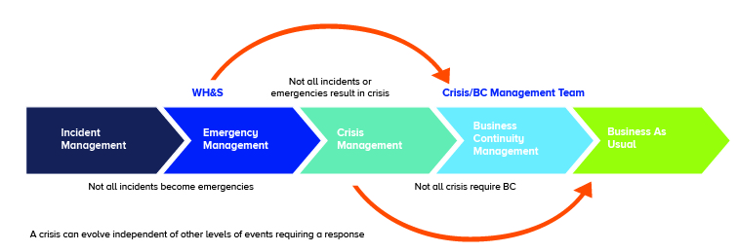

A COVID Response Team and a Crisis Management Team have been established in accordance with Chisholm’s Pandemic Response Plan. When Chisholm is notified of a suspected or confirmed COVID-19 case these teams are responsible for (but not limited to):
- Identifying any workplace contacts and providing employees, student, contractor, workplace participants and visitor records to support contact tracing.
- Advising the Department of Health and Human Services (DHHS), Department of Education and Training (DET) and WorkSafe Victoria as required.
- Complying with any directions provided by DHHS and WorkSafe as to cleaning requirements.
- Implementing cleaning protocols as required
- Notifying workers and / or students if they are a workplace contact.
- Offering welfare support to our affected employees including free and confidential counselling through our Employee Assistance and Manager Assist Programs.
- Offering welfare support to our affected students including free and confidential counselling through our Student Support and Engagement team.
- Prepare and maintain contact lists to communicate quickly and effectively with Chisholm’s employees, students, and visitors of a confirmed COVID-19 case.

