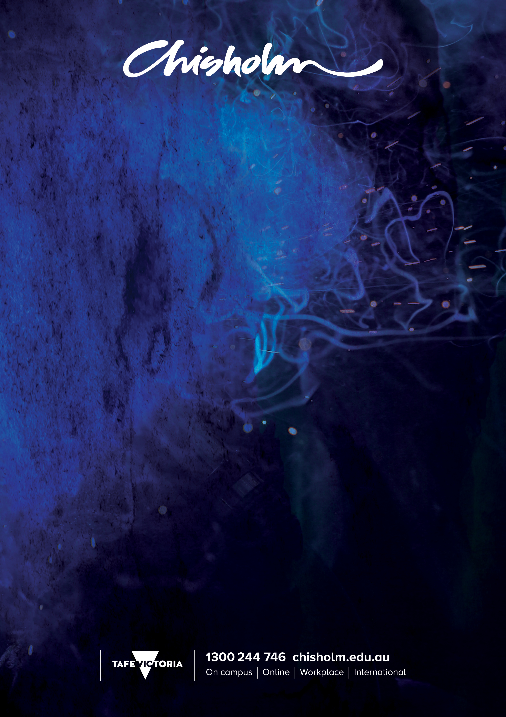

GRAPHIC DESIGN

Trade | Graphic Design
2016 QUALIFICATION | CUASS00049 Preparatory Skill Set for Professional Graphic Design Practice
UNITS OF COMPETENCY
BSBDES302 | Explore and apply the creative design process to 2D forms
BSBDES401 | Generate design solutions
CUAGRD302 | Use typography techniques
CUAGRD401 | Research and apply graphic design techniques

2016 QUALIFICATION | CUA50715 Diploma of Graphic Design
CORE UNITS OF COMPETENCY
BSBDES403 | Develop and extend design skills and practice
CUAACD501 | Refine drawing and other visual representation tools
CUAGRD501 | Research visual communication history and theory
CUAGRD502 | Produce graphic designs for 2-D and 3-D applications
CUAGRD503 | Produce typographic design solutions
CUAGRD504 | Create and manipulate graphics
CUAGRD505 | Design and manipulate complex layouts
CUAGRD506 | Develop graphic design practice to meet industry needs
CUAPRP503 | Present a body of own creative work
ELECTIVE UNITS OF COMPETENCY
CUAACD506 | Refine 2-D design ideas and processes
CUADIG507 | Design digital simulations
BSBADV509 | Create mass print media advertisements
BSBADV510 | Create mass electronic media advertisements
BSBDES402 | Interpret and respond to a design brief
BSBDES501 | Implement design solutions
CUAACD504 | Research and apply light and colour
CUADIG502 | Design digital applications
CUAPPR502 | Develop own sustainable professional practice
CUADIG401 | Author interactive media

CRICOS No 00881F RTO No 0260. Training is deliver with Victorian and Commonwealth Government funding

2016 QUALIFICATION | CUA60315 ADVANCED DIPLOMA OF GRAPHIC DESIGN
CORE UNITS OF COMPETENCY
BSBDES502 | Establish, negotiate and refine a design brief
BSBDES601 | Manage design realisation
BSBPMG522 | Undertake project work
CUAGRD601 | Engage in the business of graphic design
CUAGRD602 | Originate graphic designs for complex briefs
CUAGRD603 | Extend typographic design expertise
CUAPPR505 | Establish and maintain safe creative practice
ELECTIVE UNITS OF COMPETENCY
CUAACD512 | Work with photomedia in creative practice
CUAGRD606 | Develop graphic designs for packaging
BSBDES801 | Research and apply design theory
CUAILL501 | Develop professional illustrations
BSBIPR501 | Manage intellectual property to protect and grow business
Plus
Three other units selected from CUA50715 Diploma of Graphic Design to complete the packaging requirements

