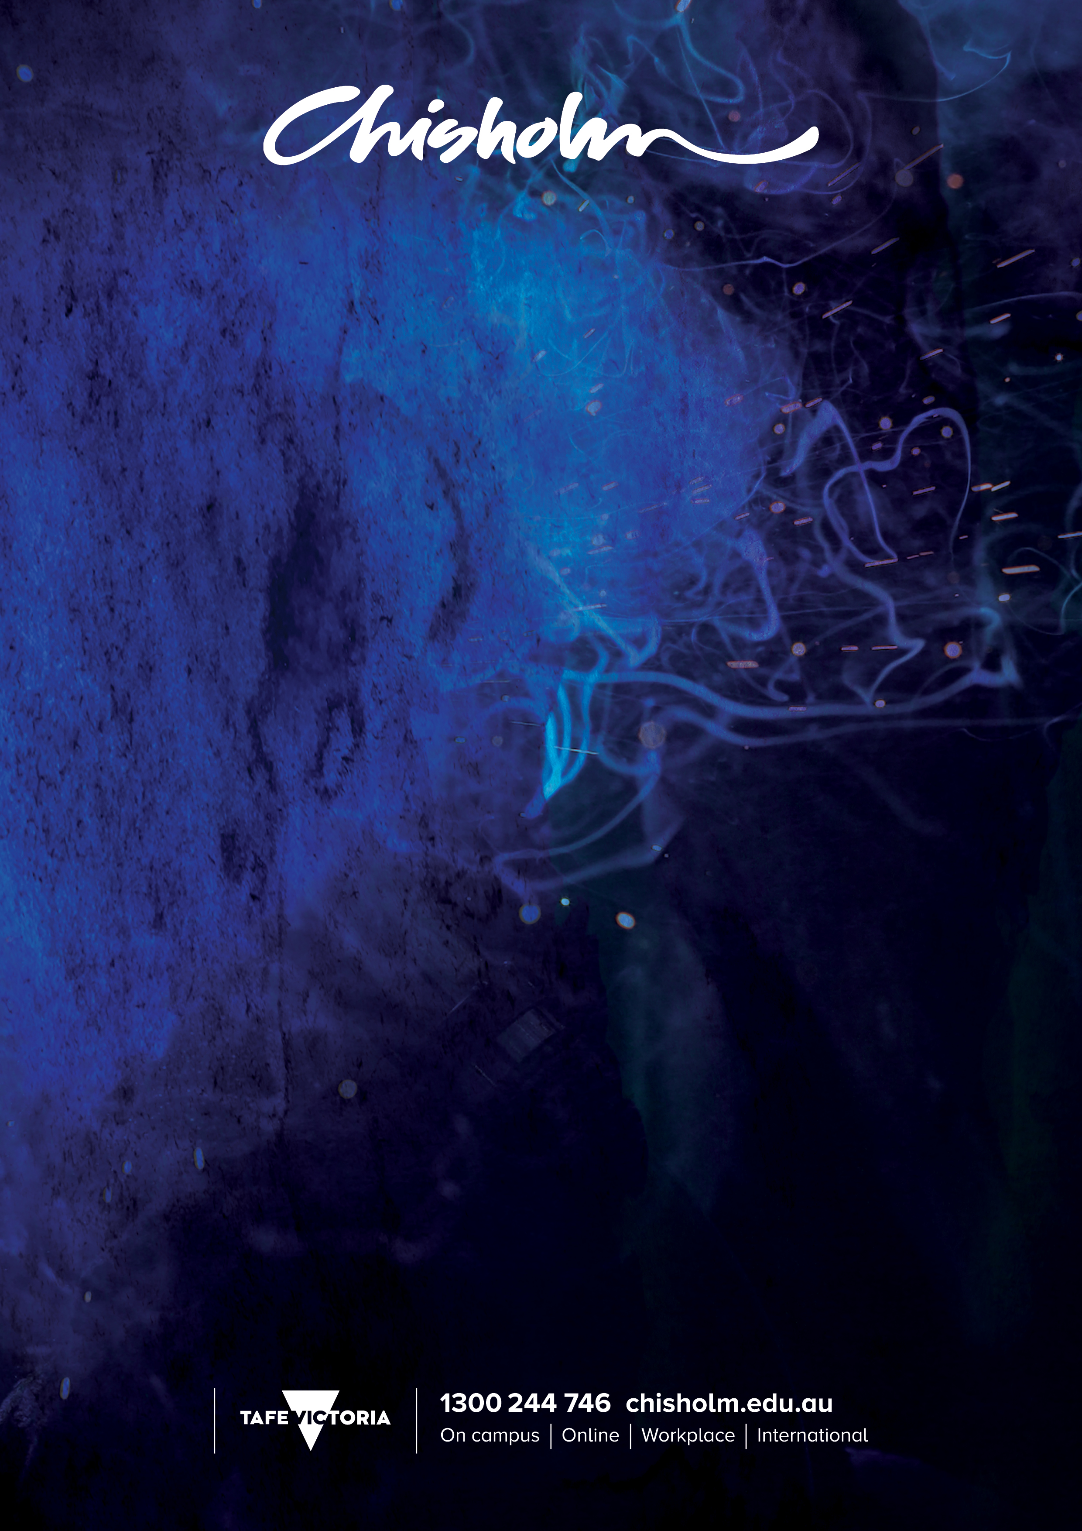

TOUR GUIDE
SIT60116 Advanced Diploma of Travel and Tourism Management (Tour Guide)
2016 QUALIFICATION

CORE UNITS OF COMPETENCY

BSBDIV501 | Manage diversity in the workplace
BSBMGT617 | Develop and implement a business plan
BSBRSK501 | Manage risk
BSBWRT401 | Write complex documents
SITTIND001 | Source and use information on the tourism and travel industry
SITTPPD008 | Develop tourism products
SITXCCS007 | Enhance customer service experiences
SITXCCS008 | Develop and manage quality customer service practices
SITXFIN002 | Interpret financial information
SITXFIN003 | Manage finances within a budget
SITXFIN004 | Prepare and monitor budgets
SITXGLC001 | Research and comply with regulatory requirements
SITXHRM003 | Lead and manage people
SITXMGT001 | Monitor work operations
SITXMGT002 | Establish and conduct business relationships
SITXMPR007 | Develop and implement marketing strategies
SITXWHS004 | Establish and maintain a work health and safety system
ELECTIVE UNITS OF COMPETENCY
Group A – 6 units
SITTTSL002 | Access and interpret product information
SITTTSL005 | Sell tourism products and services
SITTGDE004 | Lead tour groups
SITTGDE005 | Prepare and present tour commentaries or activities
SITTGDE006 | Develop and maintain the general and regional knowledge required by guides
SITXCCS002 | Provide visitor information
ADDITIONAL ELECTIVE UNITS
HLTAID003 | Provide first aid
SITTGDE002 | Work as a guide
SITXCOM002 | Show social and cultural sensitivity
SITXWHS002 | Identify hazards, assess and control safety risks

Trade | Tour Guide
2016 QUALIFICATION | SIT30516 Certificate III in Guiding
CORE UNITS OF COMPETENCY
HLTAID003 | Provide first aid
SITTGDE002 | Work as a guide
SITTGDE004 | Lead tour groups
SITTGDE005 | Prepare and present tour commentaries or activities
SITTGDE006 | Develop and maintain the general and regional knowledge required by guides
SITXCCS006 | Provide service to customers
SITXCOM002 | Show social and cultural sensitivity
SITXWHS001 | Participate in safe work practices
SITXWHS002 | Identify hazards, assess and control safety risks
ELECTIVE UNITS OF COMPETENCY
SITTTSL002 | Access and interpret product information
SIRXPDK001 | Advise on products and services
Plus any two core units from SIT60112 Advanced Diploma of Travel and Tourism (Tour Guide)

CRICOS No 00881F RTO No 0260. Training is deliver with Victorian and Commonwealth Government funding

